**Output Screenshots of the Phase1 Project**

**CONSOLE with Menu options:**

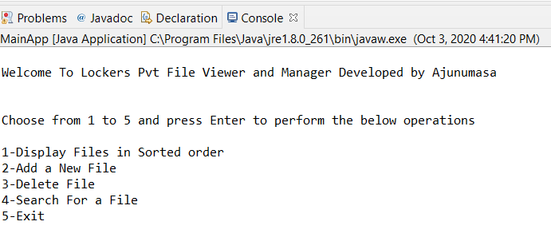

**Menu 1 - SORT and DISPLAY the Files in the Ascending Order:**

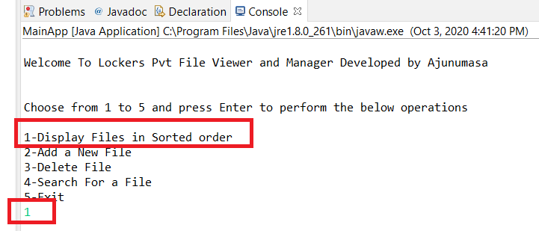

**OUTPUT**: For option “1” , Sort and Display in Ascending Order

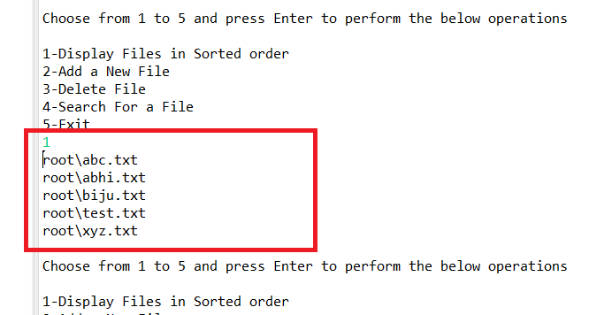

**Menu 2 - User can add new file if filename doesn’t exist in the directory**

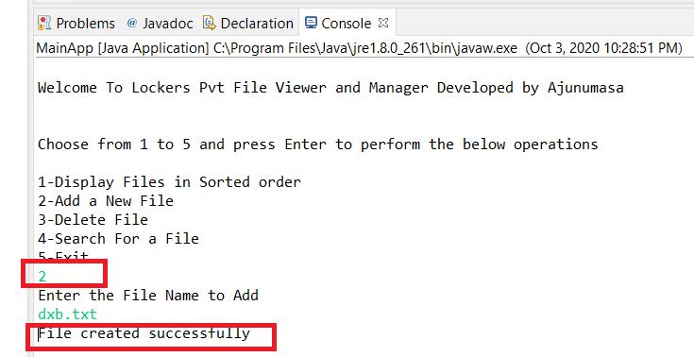

**In case if file already exist in the Root directory then it will give the output as below:**

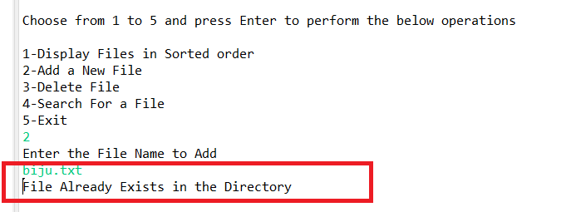

**Menu 3 - DELETE the file if exist in the root directory**

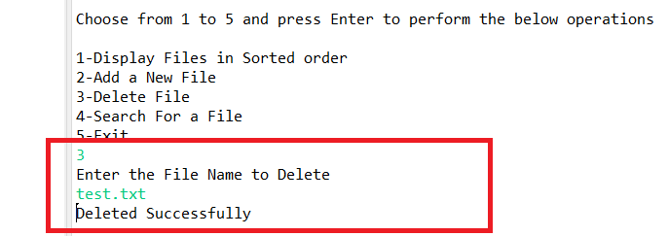

* **In case of user-entered file name not present in the root directory**

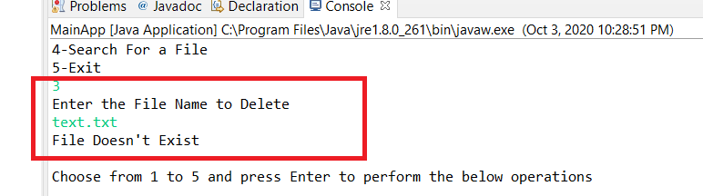

**Menu 4 – SEARCH the filename**

* searches for a file in the directory irrespective of case -sensitivity

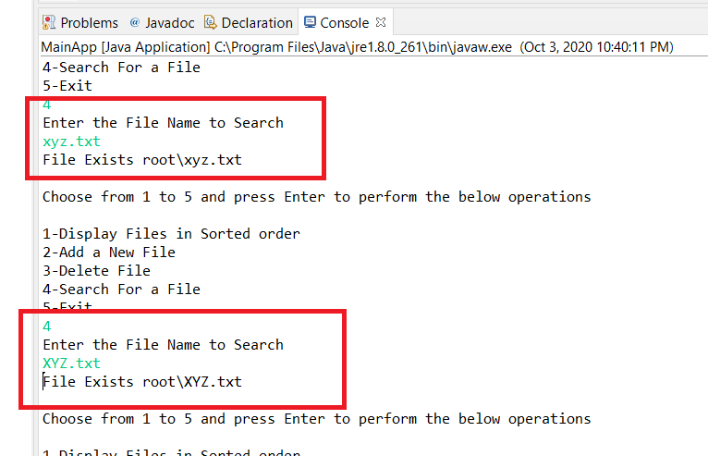

* **It will return error message as "File Not Found" if the file not exist in the directory**

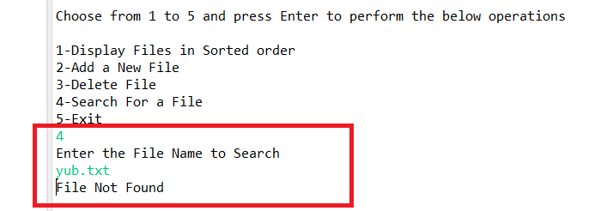

**Menu 5 – EXIT the application**

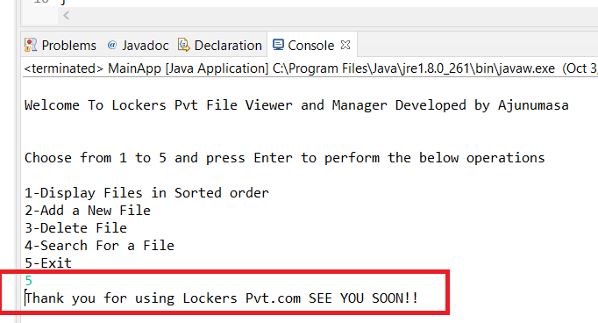

**In case if the user entered the wrong input**

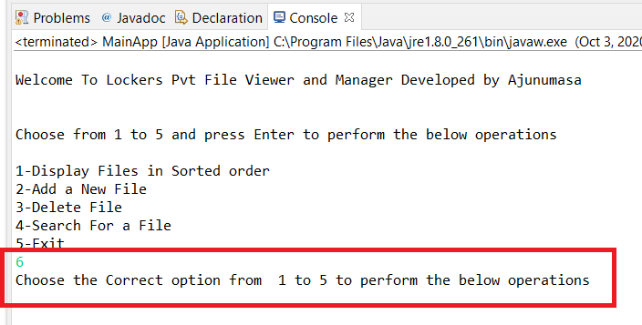

**FLOWCHART:**

